Shared publicly by Google Cloud Professional Services

| SLO Documentation  Service: <Service name> | |  |
| --- | --- | --- |
| **Intentionally left blank, for spacing.** |  |  |

# User Journey 1:

**User Details:**

**Journey Type:**

**User Goal:**

**Business Context/Criticality:**

**Journey Flow (Tasks):**

## SLI 1:

| **State** | Draft |
| --- | --- |
| **Version** | 2023-03-06 |
| **Owner** |  |
| **SLI Type** |  |
| **SLI Specification** |  |
| **SLI Implementation** |  |
| **SLO Target(s)** |  |
| **Compliance Period** |  |
| **Clarification and Caveats** |  |
| **Changelog** |  |

# [Example] User Journey: *Customer buys item through cart checkout*

**User Details:** *e.g. External Customer, new or returning*

**Journey Type:** *e.g. Request/Response*

**User Goal:** *e.g. Purchase items by completing cart checkout with items in cart*

**Business Context/Criticality:** *e.g. This is critical to our revenue and the ultimate goal of most visitors to the site*

**Journey Flow (Tasks):**

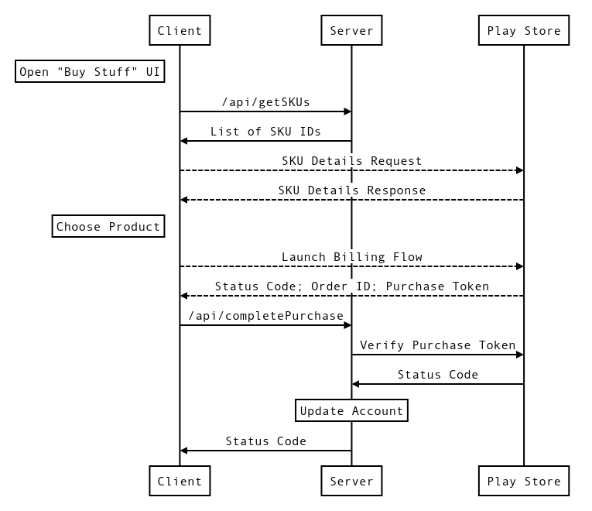

## SLI: Availability of fetching SKU data

| **State** | Active |
| --- | --- |
| **Version** | 2023-03-01 |
| **Owner** | jane.doe@example.com |
| **SLI Type** | ( Latency | **Availability** | Correctness | … ) |
| **SLI Specification** | Proportion of POST /api/getSKUs requests that return with a 2XX, 3XX, or 4XX status code as measured by the example-proj load balancer |
| **SLI Implementation** | **Cloud Operations logs-based metric**  ---  name: api-getSKU  filter: |-  resource.type="http_load_balancer"  httpRequest.requestMethod="GET"  httpRequest.requestUrl=~".*/api/getSKU$"  resource.labels.project_id="example-proj"  resource.labels.backend_service_name="example-bes"  labelExtractors:  http_status: EXTRACT(httpRequest.status)  metricDescriptor:  labels:  - description: HTTP status code  key: http_status  valueType: INT64  metricKind: DELTA  name: projects/example-proj/metricDescriptors/logging.googleapis.com/user/api-getSKU  type: logging.googleapis.com/user/api-getSKU  unit: '1'  valueType: INT64    **Cloud Operations SLO**  ---  displayName: 99.9% - Availability of fetching SKU data - Rolling 28 days  goal: 0.999  rollingPeriod: 2419200s  serviceLevelIndicator:  requestBased:  goodTotalRatio:  goodServiceFilter: metric.type="logging.googleapis.com/user/api-getSKU"  resource.type="l7_lb_rule" metric.labels.http_status>="200" AND metric.labels.http_status<"500"  totalServiceFilter: metric.type="logging.googleapis.com/user/api-getSKU"  resource.type="l7_lb_rule" |
| **SLO Target(s)** | 99.9% of requests were served successfully |
| **Compliance Period** | 28 days |
| **Clarification and Caveats** | * Request metrics are measured at the load balancer. This measurement may fail to accurately measure cases where client requests don't reach the load balancer. * We only count HTTP 5XX status messages as error codes; everything else is counted as success. * The request URI is intentionally strictly matched and does not include requests with trailing characters (e.g. URI parameters). * We do not expect any 1XX status codes. |
| **Changelog** | **YYYY-MM-DD - v1.1** Revised to include 4XX status codes as good events as historical analysis has shown these are almost exclusively input errors.  **YYYY-MM-DD - v1.0** Proposed SLOs for Cart service approved by SRE, development, and product leadership  **YYYY-MM-DD - v0.9** Initial draft of Cart Service SLOs |

## SLI: Latency of fetching SKU data

| **State** | Active |
| --- | --- |
| **Version** | 2023-03-01 - v1.1 |
| **Owner** | [jane.doe@example.com](mailto:john.doe@example.com) |
| **SLI Type** | ( **Latency** | Availability | Correctness | … ) |
| **SLI Specification** | Proportion of /api/getSKU requests that returned a 200 status code and were served sufficiently fast as measured by the example-proj load balancer  "Sufficiently fast" is defined as < 500ms or < 800ms |
| **SLI Implementation** | sum(  increase(  loadbalancing_googleapis_com:https_total_latencies_bucket{  monitored_resource="https_lb_rule",  project_id="example-proj"  backend_service_name="example-bes"  response_code_class!="500"  le="$bucket"  }[$window]  )  )  /  ignoring(le)  sum(  increase(  loadbalancing_googleapis_com:https_total_latencies_count{  monitored_resource="https_lb_rule",  project_id="example-proj"  backend_service_name="example-bes"  response_code_class!="500"  }[$window]  )  )  Note: $window is defined by the Compliance Period  $bucket ([Exponential](https://cloud.google.com/monitoring/api/ref_v3/rest/v3/TypedValue#Exponential); bucket params; targets below rounded to the nearest ms) :  50th percentile 597.6303958948906  95th percentile 836.68255425284700 |
| **SLO Target(s)** | 50% of requests are served faster than 598ms  95% of requests are served faster than 837ms |
| **Compliance Period** | 28 days |
| **Clarification and Caveats** | * Latency targets were chosen based on the closest available [distribution bucket boundary](https://cloud.google.com/monitoring/api/v3/distribution-metrics) ( le="597.6303958948906" ).  * + Bucket params:  {  "numFiniteBuckets": 66,  "growthFactor": 1.4,  "scale": 1 } * Request metrics are measured at the load balancer. This measurement may fail to accurately measure cases where user requests didn’t reach the load balancer. |
| **Changelog** | **YYYY-MM-DD - v1.1** Revised latency targets downwards based on feasibility analysis of historical data and user expectations  **YYYY-MM-DD - v1.0** Proposed SLOs for Cart service approved by SRE, development, and product leadership  **YYYY-MM-DD - v0.9** Initial draft of Cart Service SLOs |